Use star-delta / delta-star transformation to solve the following.
- Find the resistance between the terminals A and B (Figure 1). [Ans: 468.5 Ω]
- Determine the resistance between terminals A and B (Figure 2). [Ans: 6R/7]
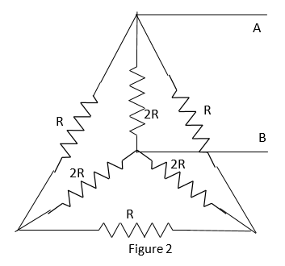
- Determine the resistance between point A and B for the network given in figure 3. [6.244 Ω]
- Calculate the equivalent resistance between points A and B by star-delta transformation (Figure 4). [Ans: 4.23Ω]
- Calculate the resistance measured between terminals A and B of the circuit shown (Figure 5). [Ans: 10.3886 Ω]
- Find the current and power supplied by the battery (Figure 6). [Ans: 1.489A, 14.89W]
- Calculate the effective resistance between points A and B of the circuit shown in figure 7. [Ans: 7Ω]
- Find the current supplied by battery to the network (Figure 8). [10/3 A]
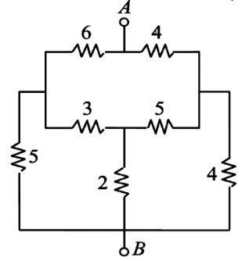
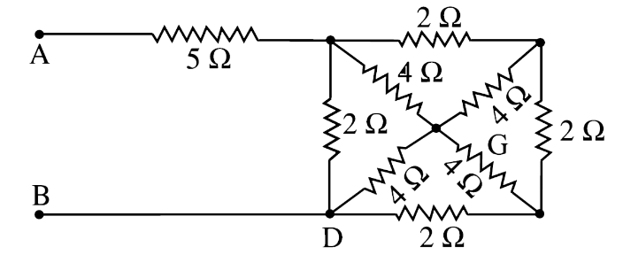
Figure 4
Figure 3
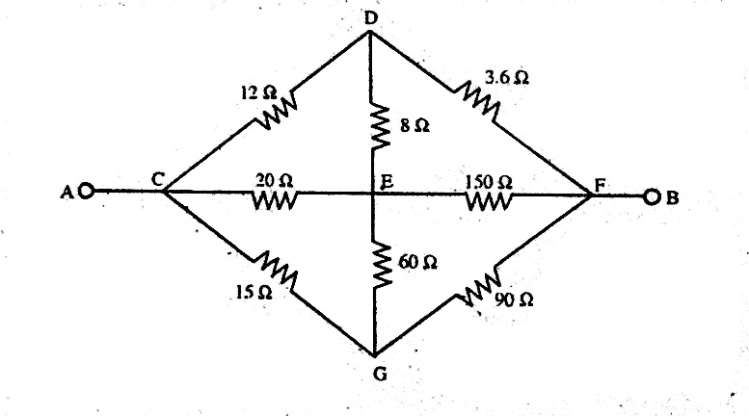
Figure 4

Figure 5

Figure 8
Figure 8

